# systemslinkreport1 (R)

This is the sheet created from Systemslink.

Col A / Site Name: A list of the site names. Some sites are duplicated

Col B / Code: This is a list of codes given to each site. On our copy all codes are unique to each site, however this may not always be the case.

Col C / Floor Area (sq mtrs) (R): This is a list of the floor area of each site in square meters.

Col D / Account Number: This is a number unique to each row. There are no duplicates, even for sites with multiple rows. This is not used in any further sheets

Col E / kWh: This is the energy each account number has used in kWh.

Col F / Cost(£): This is the cost of each site for each account number in pounds. This is not used in any further sheets.

# Site Information (R)

Col A / Name (R): This is a list of all the site names. There are no duplicates.

Col B / Floor Area (sq mtrs) (R): This is a list of the floor area of each site in square meters. Some sites have a size of 0.

Col C / UPRN: This is a list of codes given to each site. One sites use the same code as another. This matches with “Code” in “systemslinkreport1”. Sometimes the codes are an exact match, for example “Annfield Plain Library”. sometimes the “Code” is a match but except for “S01” at the end, for example “Belmont Library”. Sometimes the codes are completely different, for example “Bishop Auckland Town Hall & Library”.



# Gas 17 – 18 / Gas 18 – 19 / Gas 19 – 20 / Gas 21 – 22 Gas 22 – 23 (R)

All sheets are the same except from “Gas 19 – 20” onwards column B is renamed to “total”.

Col A / Site Name (R): This is a list of the site names. There are no duplicates.

Col B / TotalkWh (R): This is a list of values.

# Gas 24 – 25 (R+F)

Col A / Site Name (R): The name of each site is listed. If a site is listed multiple times it is highlighted in red. Highlighting is done using conditional formatting.

Col B / kWh (R+F): The kWh of each site is listed if a site is listed. If a site is listed multiple times, the first mentioned site is the sum of all duplicates. It is done this was as when a formula searches for data in this table (=VLOOKUP), it will only pull the top match i.e. the first time the site is listed.

Chester le Street Leisure Centre on row 101 doesn’t use a formula?

Durham Sixth Form Centre on row 178 has a different name to the centres it is summing.

Netpark – includes Plexus, Discovery & Explorer on row 342 has a different name to the centres it is summing and sums up multiple different centres.

# Electricity 17 – 18 / 18 – 19 / 19 – 20 / 20 – 21 / 21 – 22 / 23 – 24 (R + F)

All sheets are the same except from “Electricity 19 – 20” onwards column B is renamed to “total”.

Col A / Site Name (R): This is a list of the site names. There are no duplicates.

Col B / TotalkWh (R + F): This is a list of values. However, from “Electricity 19 – 20” onwards, “Consett Academy (new) - NO SLA” and “Consett Leisure Centre” use a formula where they take a value from column E and divide it by 0.48 and 0.52. A screenshot of a computer

# Electricity 23 – 24 (R+F)

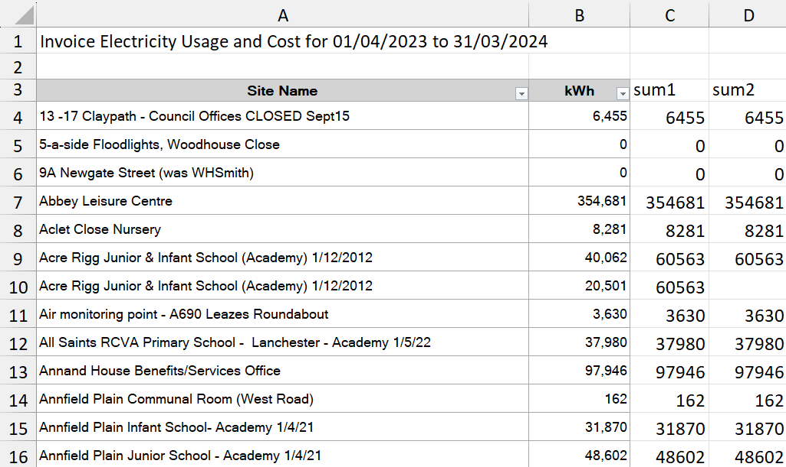

Col A / Site Name (R): This is a list of the site names. Duplicates are included.

Col B / kWh (R): The kWh of each site is listed.

Col C / sum1 (F): This column gets the total value of each site however the total value may be listed multiple times for duplicate sites.

Col D / sum2 (F): This column gets the total value of each site without duplicates.

# Gas (F)

Col A / Name (R): This is the name of each site.

Col B / Site Type: This is the type of each site.

Col C / Gas 17-18: This is the gas the site has used in kWh. It is pulled from “Gas 18 – 19” using the site name as a reference. If no data is found, a 0 is inputted.

Col D / Gas 18-19: repeat of Col C.

Col E / % change from 18-19: This is the % change from column C to column D, in decimal form rounded to the nearest whole number. e.g. a change from 18 to 40 would display as 2. If there is a 0 in column C, no number will be outputted. For column O it is written in percent form.

Columns F onwards are repeats of columns D-E.

# Electricity (F)

Col A / Name (R): This is the name of each site.

Col B / Site Type: This is the type of each site.

Col C / Gas 17-18: This is the electricity the site has used in kWh. It is pulled from “Electricity 18 – 19” using the site name as a reference. If no data is found, a 0 is inputted.

Col D / Gas 18-19: repeat of Col C.

Col E / % change from 18-19: This is the % change from column C to column D, in decimal form rounded to the nearest whole number. e.g. a change from 18 to 40 would display as 2. If there is a 0 in column C, no number will be outputted. For column I onwards, it is written in percent form. An increased percentage is coloured red and a decreased percentage is coloured green.

Columns F -P are repeats of columns D-E.

Col Q / % change from first year: This is the same as column E but using the data from the first and most recent year.

# Emissions Factors (R)

Col A / Year: This is the year

Col B / Gas: This is a figure. Not sure where it is from, but it is used in “Carbon Emissions.”

Col C / Electricity: This is a figure. Not sure where it is from, but it is used in “Carbon Emissions.”

There is no data from 17-18 and 18-19. We will either have to ask for the missing data for the spreadsheet to be complete, or some data will not be available for those years.

# Carbon Emissions (F)

Col A / Name (R): This is the name of each site.

Col B / Site Type: This is the type of each site.

Electricity xx – xx: This contains the electricity usage in kWh for electricity for the specified year.

Gas xx – xx: This This contains the electricity usage in kWh for gas for the specified year.

Total Emissions xx – xx: This is from the formula  
(“Electricity xx – xx” * “Emissions Factors!Electricy”) + (“Gas xx – xx” * “Emissions Factors!Gas”)

% Change xx – xx: This is the percentage change of total emissions from the previous year, in percentage form. An increased percentage is coloured in red and a decreased percentage is coloured in green.

Col Y / Responsible Person: This contains some names manually added to the spreadsheet.

# Carbon as a Percentage

Col A / Name (R): This is the name of each site.

Col B / Site Type: This is the type of each site.

Emissions xx – xx: This is the total emissions from “Carbon Emissions.”

% of total emissions xx – xx: This is the percentage of that years total emissions, in decimal form.

L1: This is the total emissions for 22-23

M1: This is the total emissions for 23-24

N1: This is the percentage change between 23-24 and 22-23, in percentage form.

# Gas sites as a percentage

This is an incomplete spreadsheet. I believe it should function like “Elec as a percentage.”

# Elec as a percentage

Col A / Name (R): This is the name of each site.

Col B / Site Type: This is the type of each site.

Electricity xx – xx: This is the electricity in kWh used by each site.

% of total emissions: This is the electricity generated by the site as a percentage of each years total electricity.

M1: Total electricity of 22 – 24

O2: Total electricity of 23 – 24

# Annual HDD (R)

This is a table of raw data. It appears to be downloaded from Systemslink.

# kWh per HDD

Col A / Name (R): This is the name of each site.

Col B / Site Type: This is the type of each site.

kWh/HDD xx – xx: This is the formula  
kWh of Gas for that year / The total HDD of the year.

% change from xx – xx: This is the percentage change from the previous year. It is coloured green if it has decreased and coloured red if it has increased.